**Project Report**

**Atal Bihari Vajpayee Indian Institute of Information Technology and Management, Gwalior**



**DBMS PROJECT**

TOPIC: Airport and Flight Database Management

Submitted by-

* Amit Raman – 2019BCS-007
* Utsav Verma – 2019BCS-068
* Kislay Singh – 2019BCS-030
* Amit Nirmal – 2019BCS-006

**Real-Life Problem Statement:**

A database management system of an international airport. The efficient and easy management of this data will allow the airport and the flights to run smoothly and can save a lot of delay related problems the airport and the passengers can suffer from.

* It consists of all the flights travelling to-and-from this airport at an instance of time.
* It also contains the schedule of all the flights, is corresponding airlines and also the staff on it.
* Along with this data of flights, the database also contains the information of all the airport employees in their respective departments.
* There is also information about the runways, conveyor belts, and shops available at the airport. Also the database contains the information about the passengers.

**Entity Sets:**

1. **Airlines** – All the airline companies related to the airport.
2. **Flights** – Flights with their departure and arrival timings.
3. **Airline** **Staff** – Staff of all the particular airline.
4. **Passengers** – The people arriving or departing from the airport.
5. **Employees** – Airport staff.
6. **Shops** –All the shops at the airport.
7. **Cargo** – The deliveries being transported through the airport.
8. **Runways** – Details about all the runways.
9. **Conveyor Belts** – The belts available for baggage on the airport for arriving airplanes
10. **Immigration** – The details of the people immigrating and their immigration details as well as customs.

**Relationship Sets:**

1. **Operates –** Many to One Relation between flights with total participation and airlines partial participation indicating which flight belongs to which airlines.
2. **Works-for –** One to Many Identifying relations between Airlines with total participation and Airline-Staff with total participation, indicating the employees for the particular airlines.
3. **On-Board Staff –** One to Many Relation between the Flights with total participation and Airline-Staff with partial participation, indicating the staff which is on-board the particular staff.
4. **Take-Off –** One to One Relation between Flights with total participation and Runways with total participation, indicating which is operating on which runway.
5. **Shipping –** Many to One Relation between Cargo with total participation and Flights with partial participation, indicating the cargo on each flight.
6. **On-Board –** Many to One Relation between passengers with total participation and flights with partial participation, indicating the passengers on-board a flight.
7. **Ground-Handling** **Staff** – Many to One Relation between Employees with partial participation and Runways with total participation, indicating the employees who are working on the runways.
8. **Courier** **Management** – Many to One Relation between Cargo with total participation and Employees with partial participation, indicating the Employees handling the deliveries through the airport.
9. **Seller** – One to Many Relation between Shops with total participation and Employees with partial participation, indicating the employees are responsible for maintaining the shops available at the airport.
10. **Immigration Officer** – One to Many Relation between Employees with partial participation and Immigration with total participation, indicating the immigration officer for the immigrants.
11. **International Arrival** –One to One Relation between passengers with partial participation and immigration with total participation, indicating all the passengers who are indicating.
12. **Baggage** – Many to Many Relation between flights with total participation and conveyor belts with partial participation, indicating the luggage from particular flights onto particular belts.

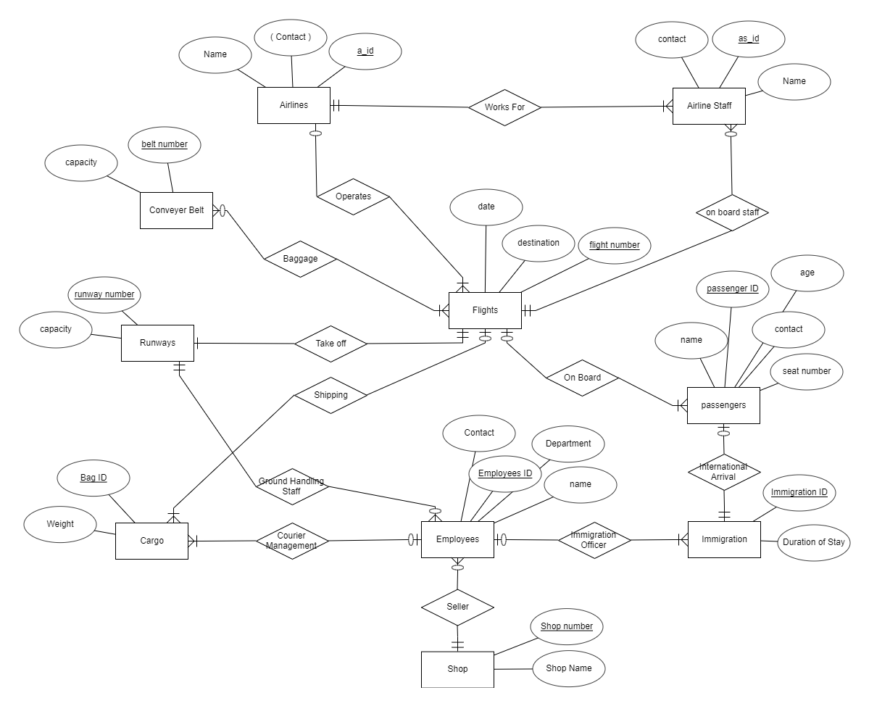**E-R Diagram-**

**Relational Schema-**

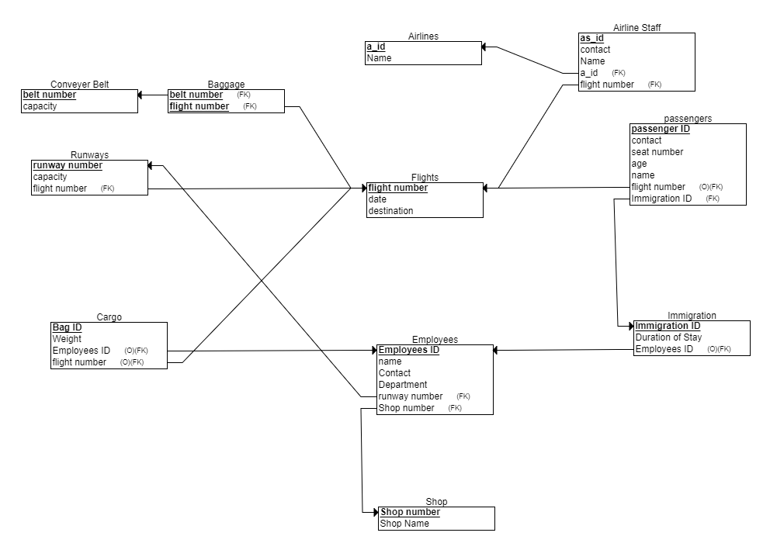

**PARTICIPATION CONSTRAINTS:**

* Flights : Airlines = Total : Partial
* Airlines : Airlines Staff = Total: Total
* Flights : Airlines Staff = Total : Partial
* Flights : Conveyer Belts = Total : Partial
* Flights : Runways = Total : Total
* Cargo : Flights = Total : Partial
* Passengers : Flights = Total : Partial
* Passengers : Immigration = Partial : Total
* Employees : Immigration = Partial : Total
* Employees : Runways = Partial : Total
* Cargo: Employees = Total: Partial
* Shops: Employees = Total: Partial

**CARDINALITY CONSTRAINTS:**

* Flights : Airlines = m : 1
* Airlines : Airlines Staff = 1: m
* Flights : Airlines Staff = 1: m
* Flights : Conveyer Belts = m : n
* Flights : Runways = 1 : 1
* Cargo : Flights = m : 1
* Passengers : Flights = m : 1
* Passengers : Immigration = 1 : 1
* Employees : Immigration = 1 : m
* Employees : Runways = m : 1
* Cargo : Employees = m : 1
* Shops: Employees = 1: m

INITIAL SCHEMA:

FIRST NORMAL FORM –

* Airlines (Airline Code, Name, Contact)
* Airline Staff (Staff ID, Name, Contact)
* Flights (Flight Number, Destination, Date)
* Conveyer Belts (Belt Number, Capacity)
* Runways (Runway Number, Capacity)
* Shipping ( Bag ID, Flight Number)
* Cargo (Consignment ID, Weight)
* Passengers (Contact, Name, Seat Number, Age, ID)
* Employees (Employee ID, Name, Contact, Department)
* Immigration (Immigration ID, Duration of Stay)
* Seller (Employee ID, Shop Number)
* Shop (Shop Name, Shop Number)

FUNCTIONAL DEPENDENCIES-

Airlines Table:

Airline Code -> Name, Contact

Airline Staff Table:

Staff ID -> Name, Contact

Flights Table:

Flight Number -> Destination, Date

Conveyer Belts Table:

Belt Number -> Capacity

Runways Table:

Runway Number -> Capacity

Cargo Table:

Consignment ID -> Weight

Passengers Table:

ID -> Name, Contact, Seat Number, Age

Employees Table:

Employee ID -> Name, Contact, Department

Department -> Contact

(partial dependency)

Immigration Table:

Immigration ID -> Duration of Stay

Shop Table: Shop Number -> Shop Name

SECOND NORMAL FORM:

* Airlines (Airline Code, Name, Contact)
* Airline Staff (Staff ID, Name, Contact)
* Flights (Flight Number, Destination, Date)
* Conveyer Belts (Belt Number, Capacity)
* Runways (Runway Number, Capacity)
* Shipping ( Bag ID, Flight Number)
* Cargo (Consignment ID, Weight)
* Passengers (Contact, Name, Seat Number, Age, ID)
* Employees (Employee ID, Name, Contact, Department)
* Department(Department,Contact)
* Immigration (Immigration ID, Duration of Stay)
* Seller (Employee ID, Shop Number)
* Shop (Shop Name, Shop Number)

THIRD NORMAL FORM:

There are no transitive dependencies in any of above tables, therefore above tables are already in Third Normal Form.

QUERIES:

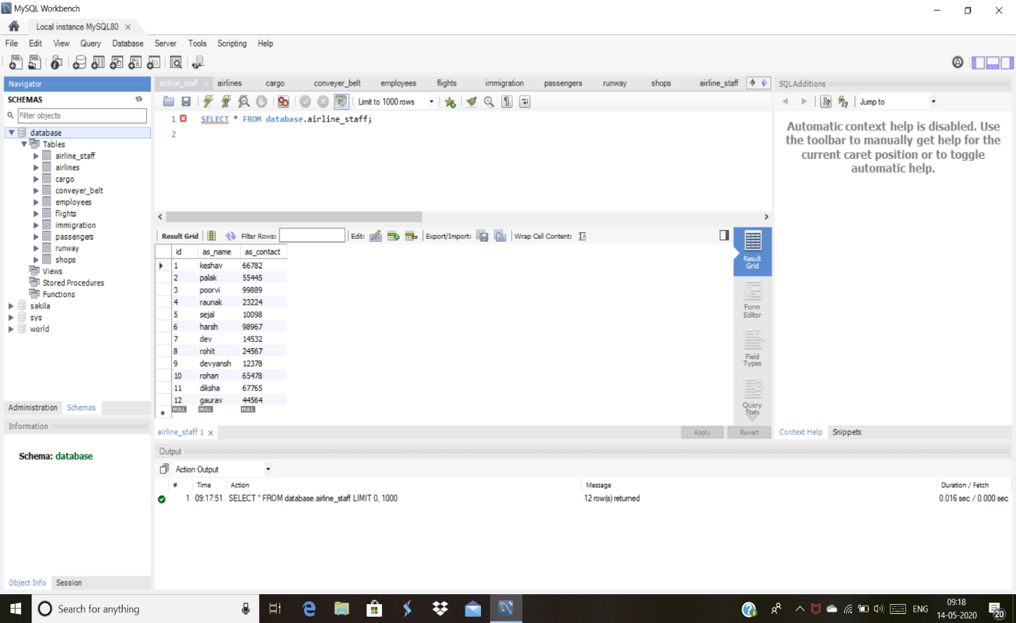

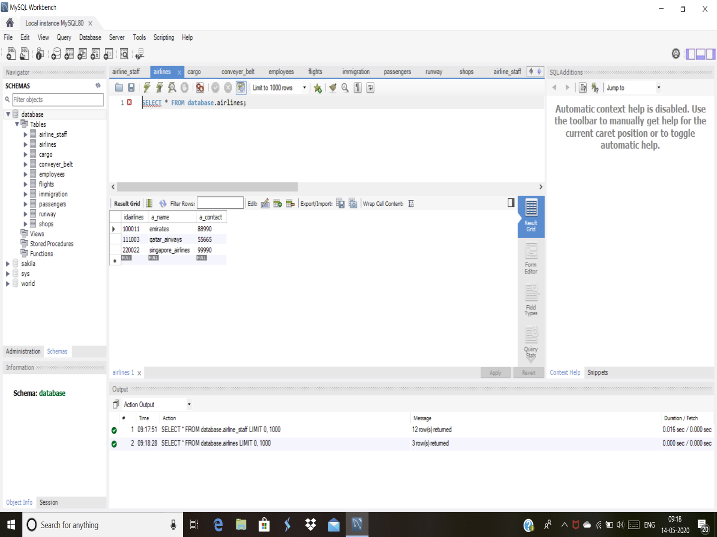

QUERIES:

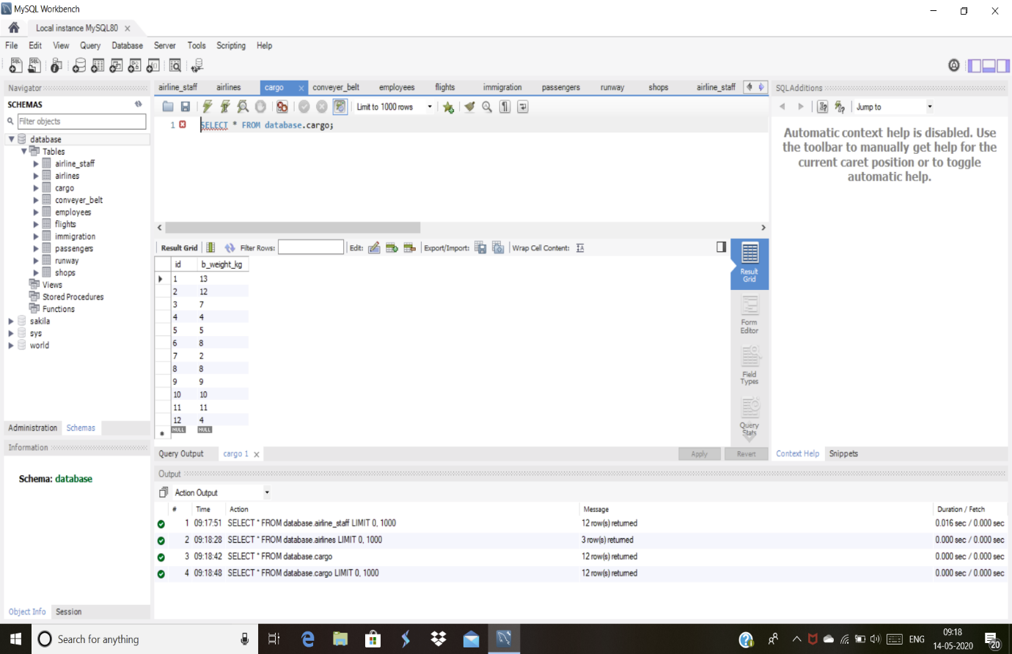

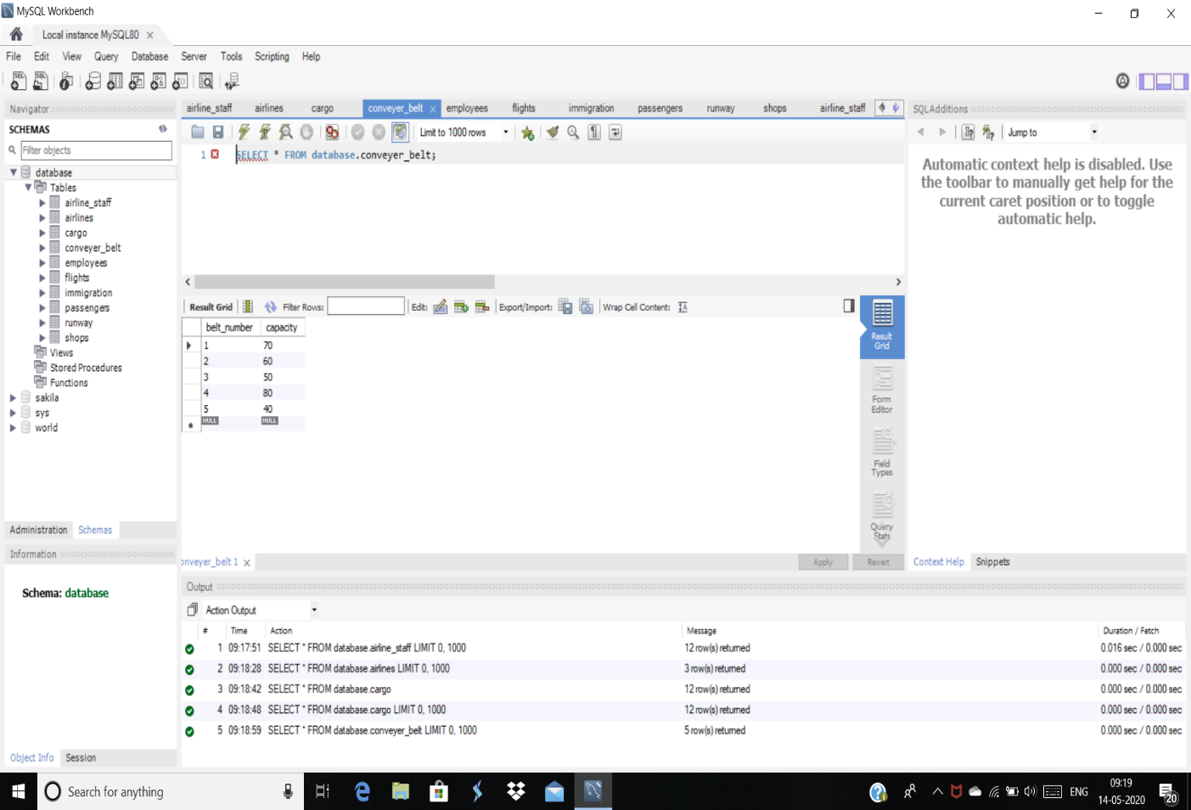

QUERIES:

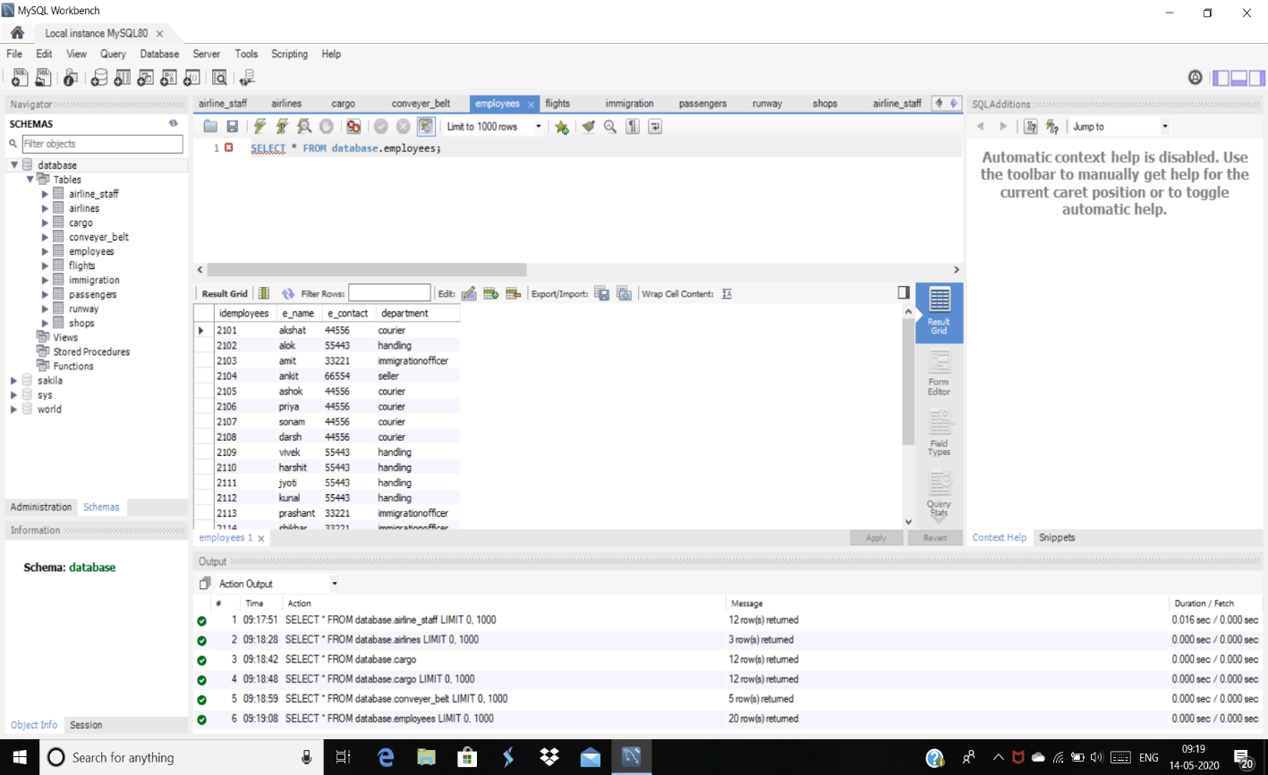

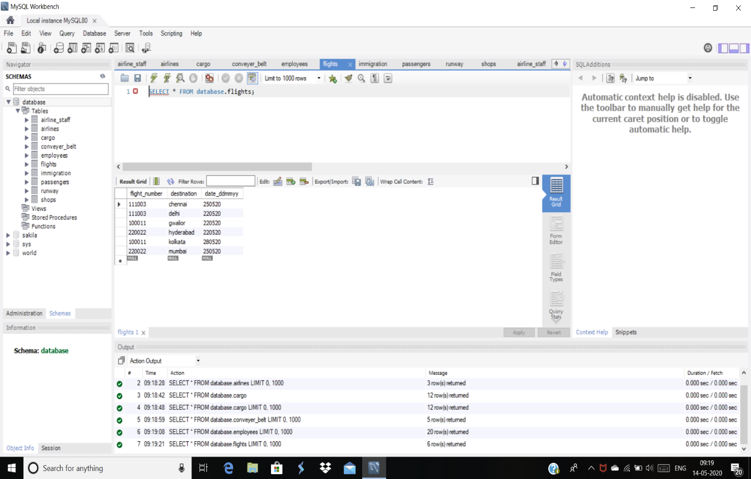

QUERIES:

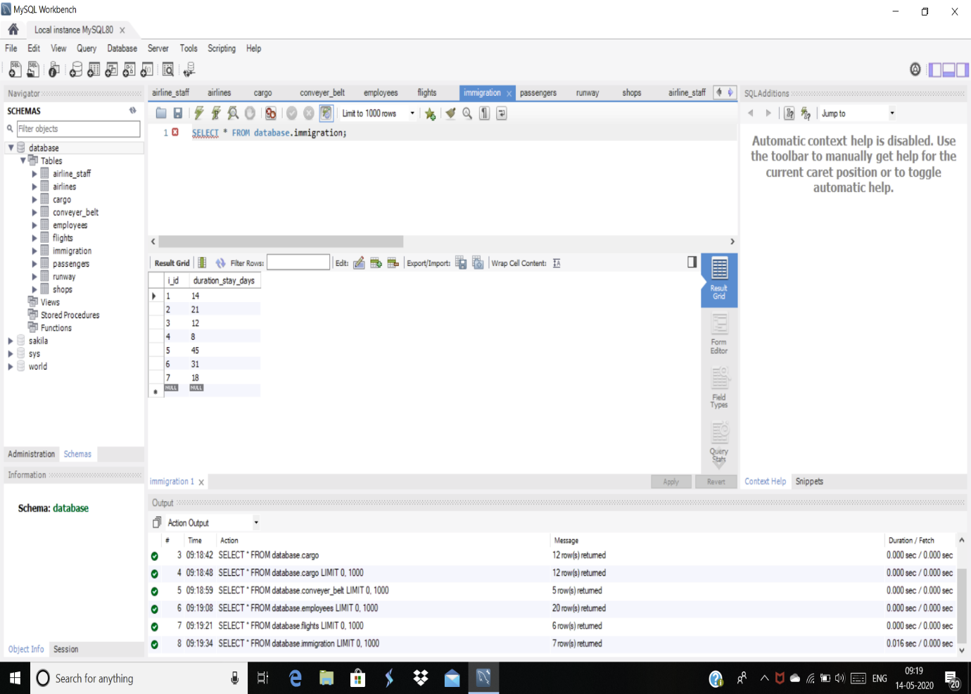

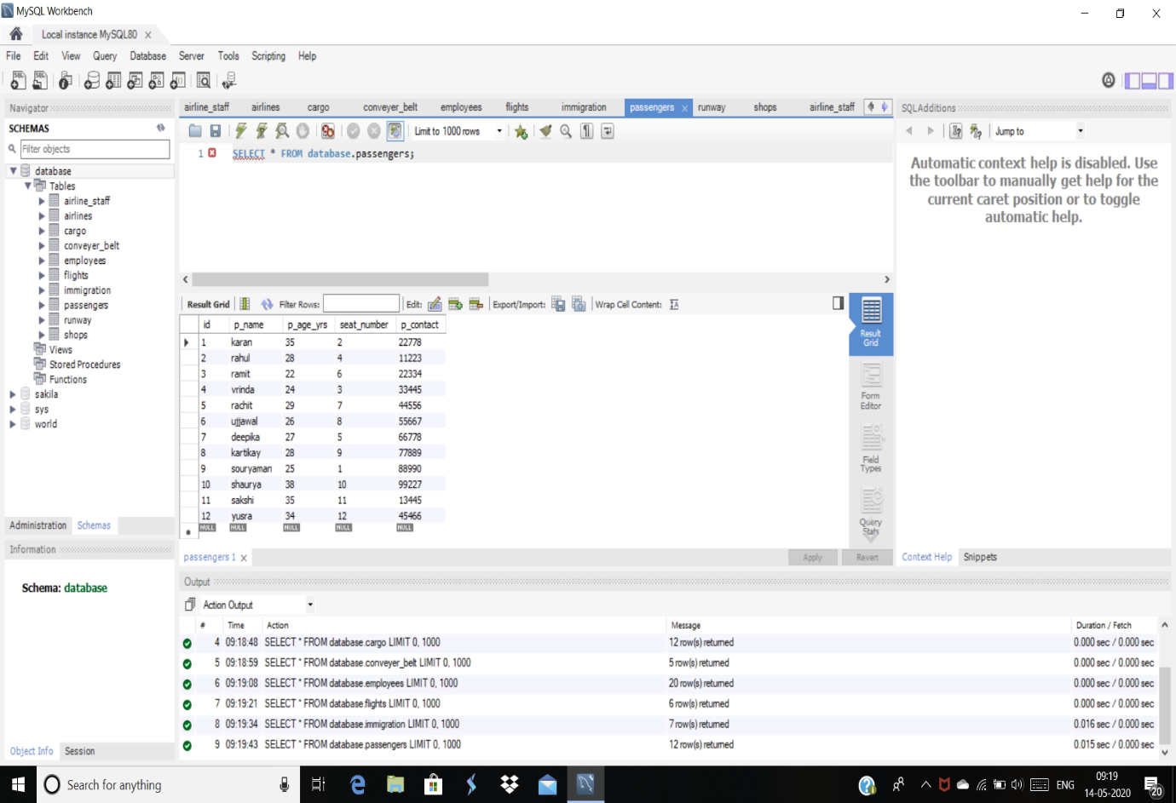

QUERIES:

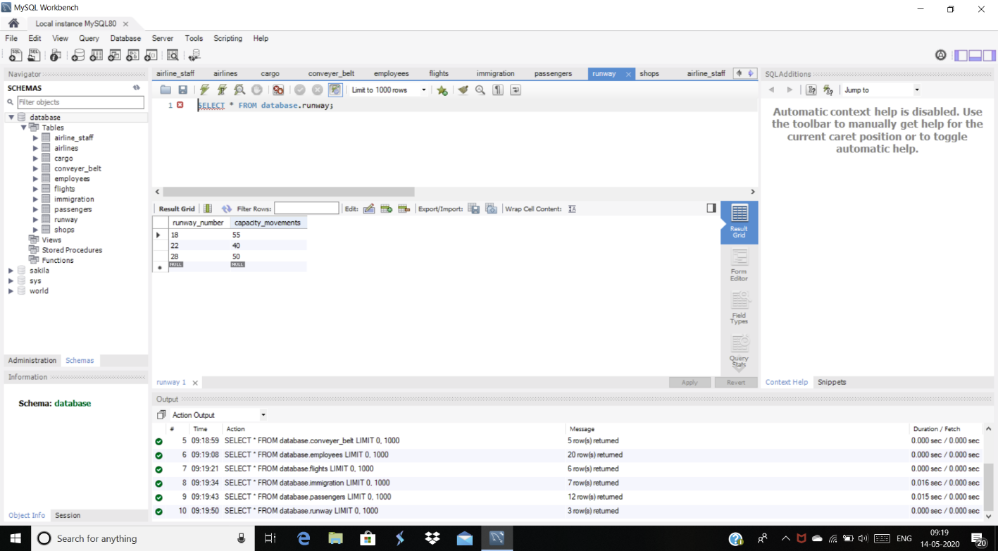

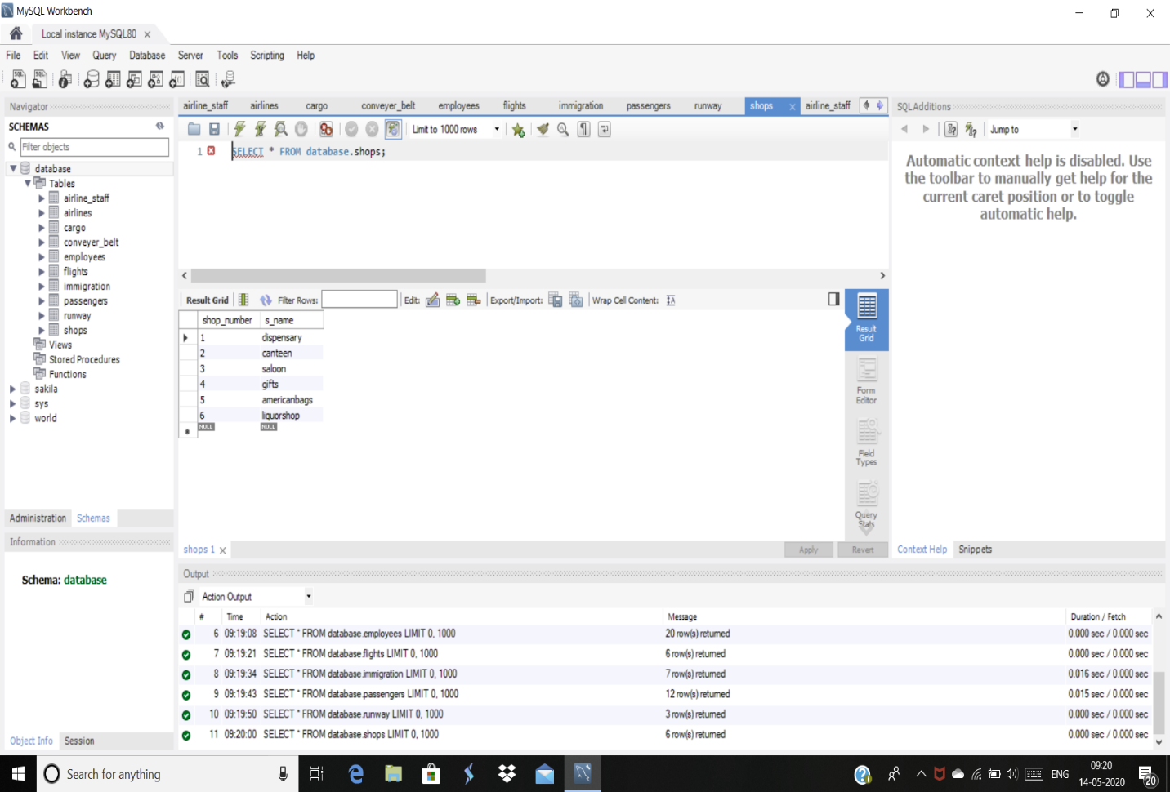

ER DIAGRAM REPRESENTATION

(INCLUDING TABLES IN MYSQL WORKBENCH)

